Adicionando Rota

.state(**'client.checkout_orders'**, {  
 **cache**: **false**,  
 **url**: **'/checkout/orders'**,  
 **templateUrl**: **'templates/client/checkout-orders.html'**,  
 **controller**: **'ClientCheckoutOrderListCtrl'**})

Controller ClientCheckoutOrderList

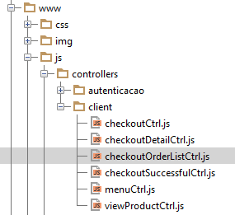

Chamar na index.html

<**script src="js/controllers/client/checkoutOrderListCtrl.js"**></**script**>

No services orderSrv.js adicionar mais um serviço OrderList

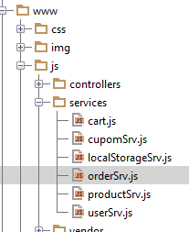

OrderList

angular.module(**'starter.services'**)  
 .**factory**(**'Order'**, [**'$resource'**, **'appDevConfig'**, **function** ($resource, appDevConfig) {  
 **return** $resource(appDevConfig.**baseUrl** + **'api/client/order/:id'**, {**id**: **'@id'**}, {  
 **query**: {  
 **isArray**: **false** }  
 });  
}]);  
  
angular.module(**'starter.services'**)  
 .**factory**(**'OrderList'**, [**'$resource'**, **'appDevConfig'**, **function** ($resource, appDevConfig) {  
 **return** $resource(appDevConfig.**baseUrl** + **'api/client/order/?include=:include'**, {**include**:**'items,deliveryman'**}, {  
 **get**: {  
 **isArray**: **false** }  
 });  
 }]);

Controller ClientCheckoutOrderList

**angular**.module(**'starter.controllers'**)  
 .**controller**(**'ClientCheckoutOrderListCtrl'**,[  
 **'$scope'**, **'$state'**, **'OrderList'**, **'$ionicLoading'**,  
 **function** ($scope, $state, OrderList, $ionicLoading) {  
 $scope.**orders** = [];  
  
 $ionicLoading.**show**({  
 **template**: **'Carregando...'** });  
  
 OrderList.get({}, **function**(data) {  
 $scope.**orders** = data.data;  
 $ionicLoading.**hide**();  
  
 }, **function**(responseError) {  
 $ionicLoading.**hide**();  
  
 });  
  
  
  
 }]);

Criar View checkout-orders.html

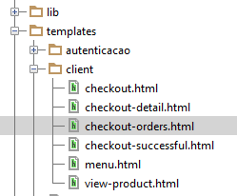

<**ion-view**>  
 <**ion-nav-title**>Meus Pedidos</**ion-nav-title**>  
 <**ion-content class="padding has-header"**>  
 <**ion-list**>  
 <**ion-item ng-repeat="o in orders"**>  
 <**div class="row"**>  
 <**div class="col"**>  
 Teste {{$index}}  
 </**div**>  
 <**div class="col"**>  
 Teste {{$index}}  
 </**div**>  
 </**div**>  
  
  
 ID: #{{o.id}}<**br** />  
 Date: {{ o.created_at.date}}<**br** />  
 Status: {{ o.status}}<**br** />  
 QTD Items: {{ o.items.data.length }}  
 <**span class="item-note"**>  
 <**i class="ion ion-cash"**> R$ {{o.total}}</**i**>  
 </**span**>  
 </**ion-item**>  
 </**ion-list**>  
 </**ion-content**>  
</**ion-view**>